**SEU/IS/22/ICT/075**

**Subject Code:**  CIS11042

**Subject Name:** Essential of ICT and PC Application

**Title:**

**MS Excel (work with data)**

**Labsheet:**13

Department of Information and Communication Technology

Faculty of Technology

South Eastern University of Sri Lanka

Aims:

* Sort and filter data.
* View options.
* Pivot tables

Task 01

1. 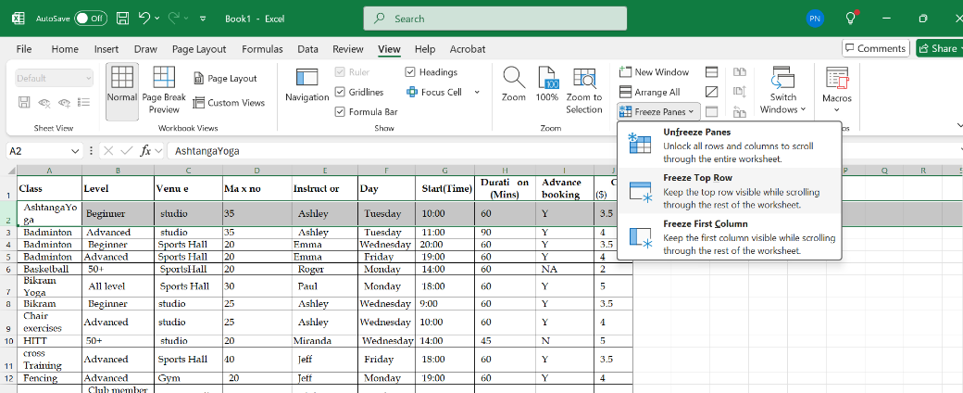
2. first column 🡪 View 🡪 Freeze panes 🡪 Freeze first column option

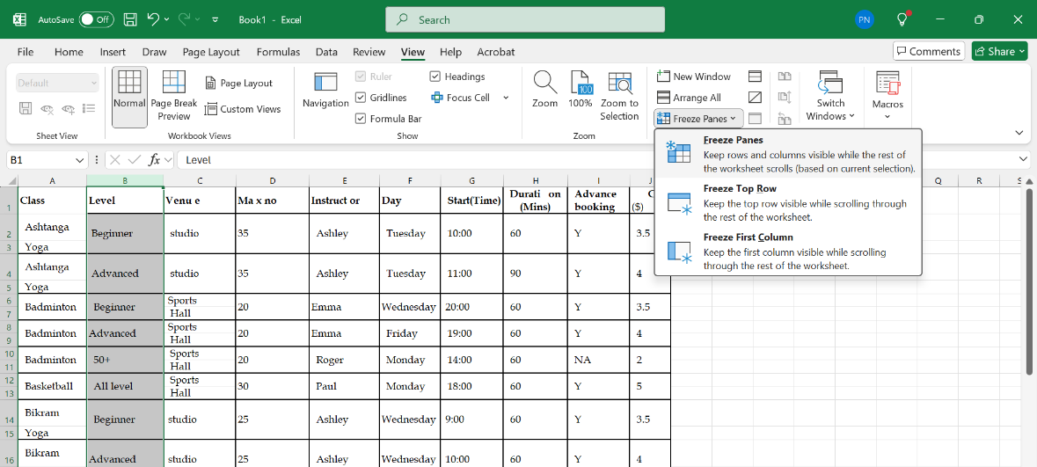

1. first column 🡪 View menu 🡪 Freeze panes 🡪 Unfreeze panes

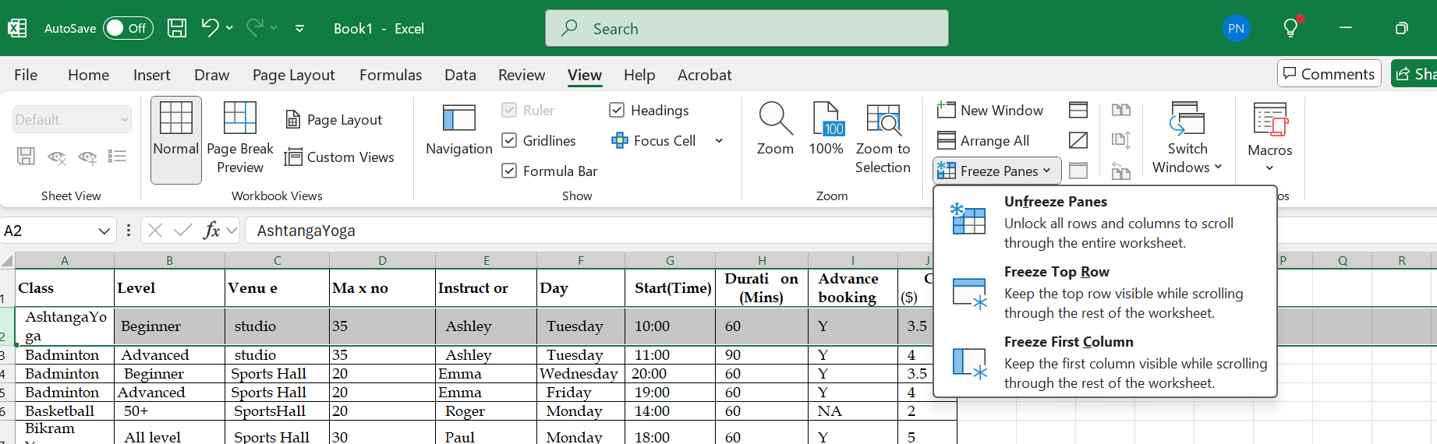

1. 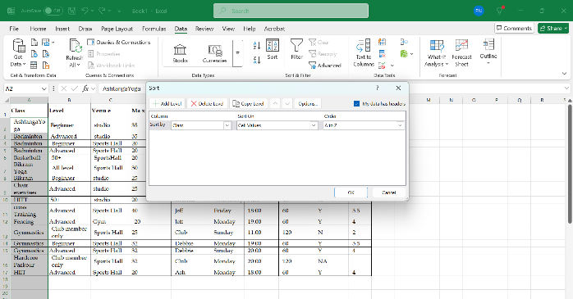

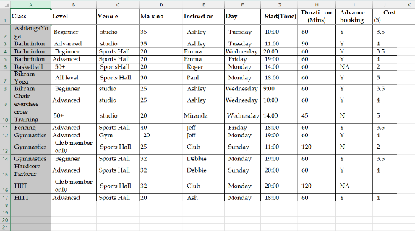Output

1. 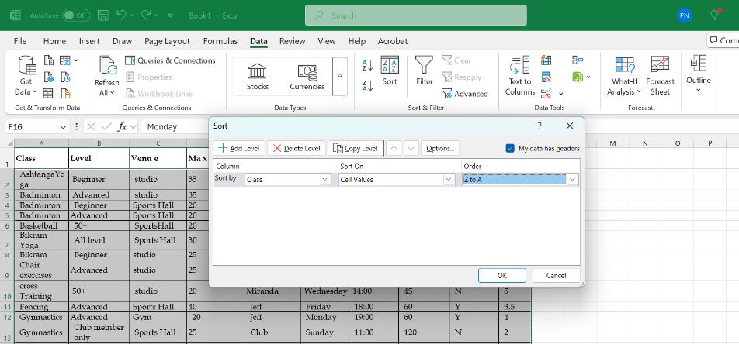

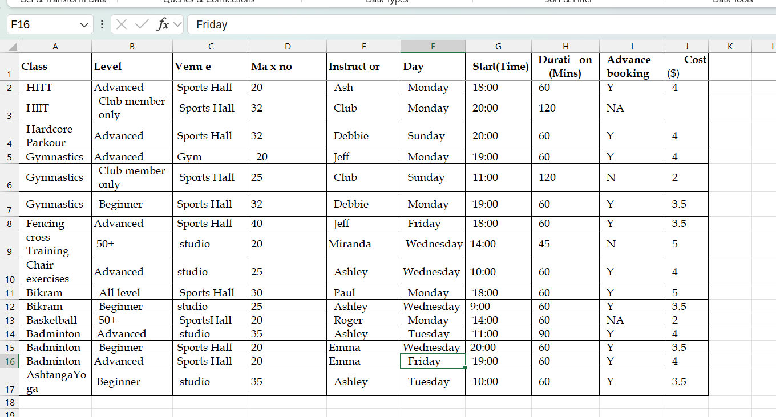 Output 🡪

1. Select All table 🡪 Sort 🡪 Add Multiple level 🡪 Choose column and Order 🡪 Ok

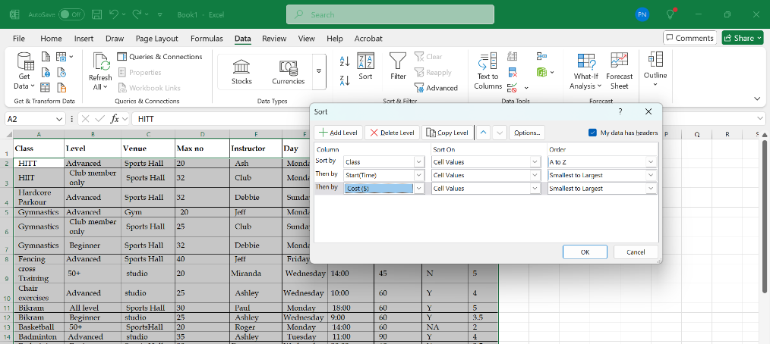

1. 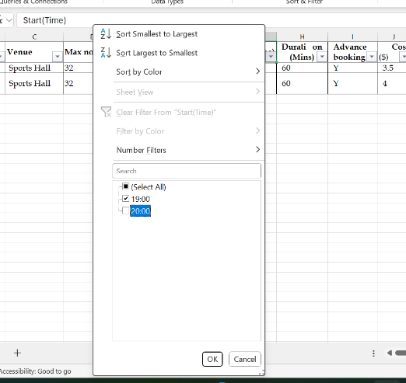Select all table 🡪 Data menu 🡪 filter option

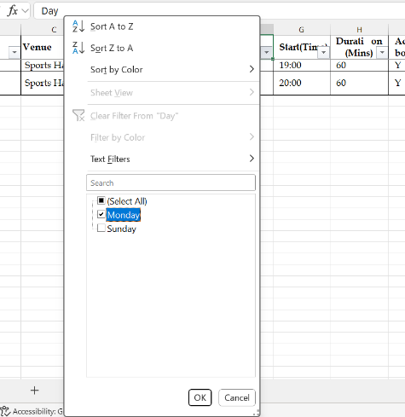Output🡪

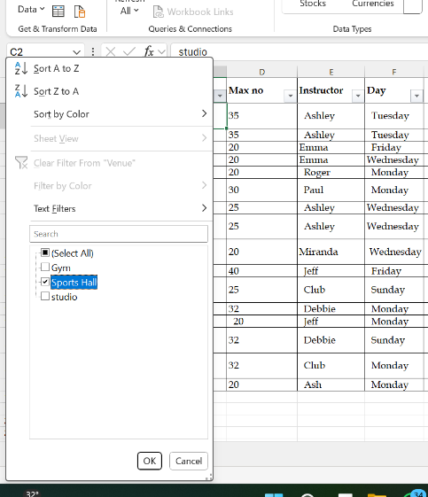

1. A screenshot of a computer

   AI-generated content may be incorrect.

Sports hall Wednesday

Grader than or equal to 20.00

1. Select the table 🡪 Insert menu 🡪 Pivot table 🡪 ok

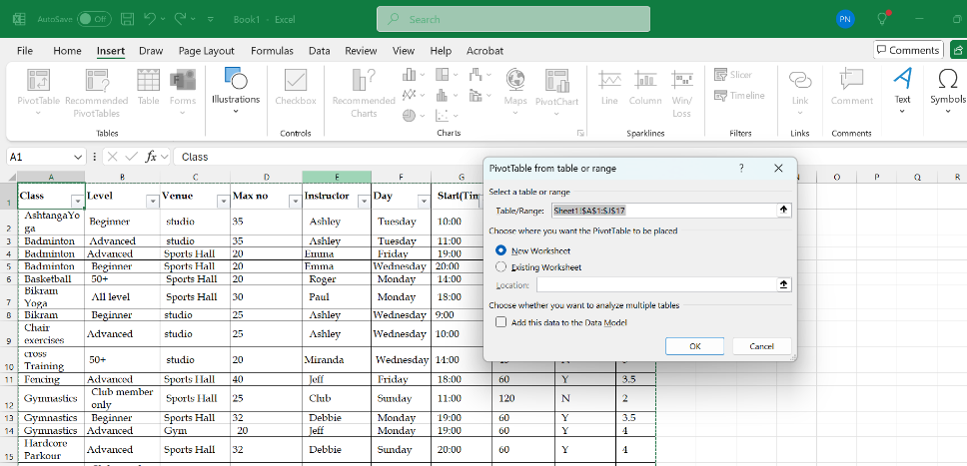

(Create a pivot table)

Sum of each classes

(Drag and drop the class into Row section and Cost into value section)

1. A screenshot of a computer

   AI-generated content may be incorrect. Output🡪

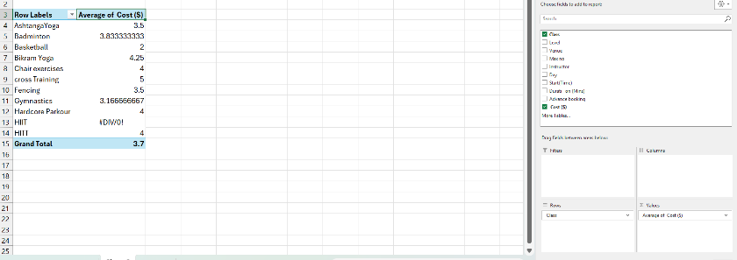

Exercise 01

1. Select the all table 🡪 insert 🡪 pivot table 🡪 From table/Range 🡪 Check the range 🡪 Ok

1. Select the “Account column” 🡪 Change number format to Accounting

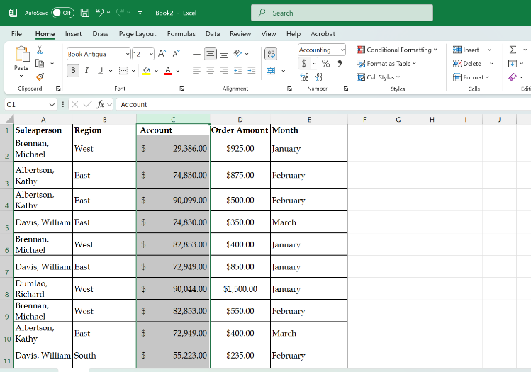

1. Click on the Pivot table 🡪 Insert Menu 🡪 Chart section 🡪 Choose and click of chart

1. Drag and drop “Salesperson”, “Region”, “Account”, “Order amoun” into filter section

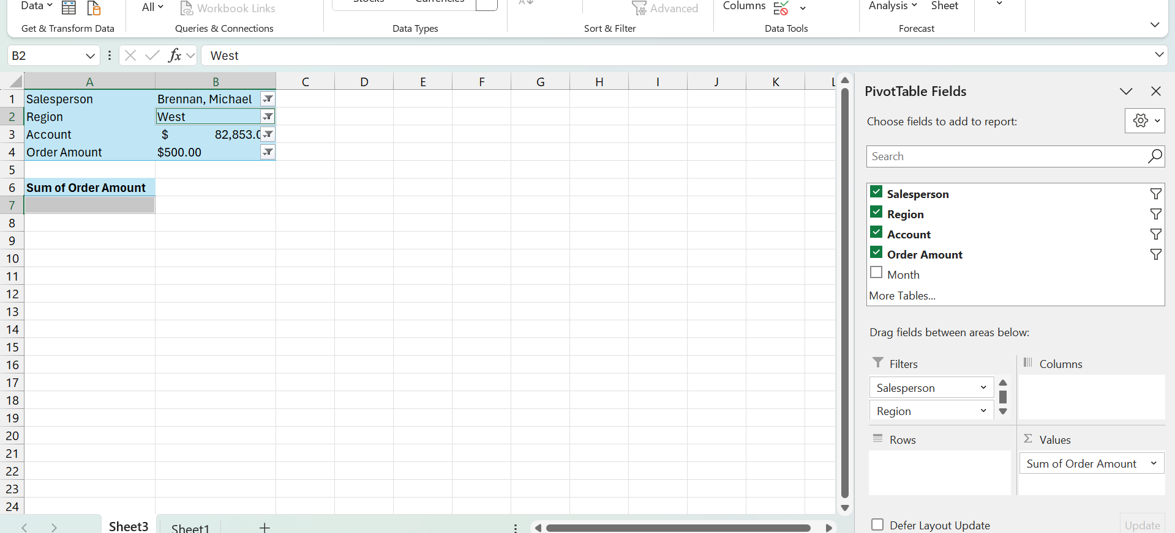

1. Drag and drop salesperson into value section and region into row section

